

JOMO KENYATTA UNIVERSITY OF AGRICULTURE AND TECHNOLOGY BACHELOR OF SCIENCE IN COMPUTER SCIENCE DEPARTMENT OF COMPUTING

FINAL PROJECT

AN AUTOMATED APPROACH TO MONITORING AND REGULATION OF ELEMENTS IN FARMING

GROUP MEMBERS

Martin Miano Kariuki
David Langat

SCT211-0668/2016

SCT211-0537/2016

DECLARATION

This research project is our original work and has not been presented for any other degree in any other University.


Signature …………………………………………. | 2/9/2021
Signature …………………………………………. | Date…………………………………………
MARTIN MIANO KARIUKI SCT211-0668/2016.


Signature …………………………………………. |  | 2/9/2021
 |  | Date…………………………………………
DAVID LANGAT | SCT211-0537/2016.

This research project has been submitted for examination with our approval as University Supervisors.

 10th Feb 2021
Signature …………………………………………. Date…………………………………………

Mr. BRIAN MURIITHI.
Table of Contents

DECLARATION 2

DEDICATION 5

ACKNOWLEDGMENT 6

CHAPTER 1 7

ABSTRACT 7

INTRODUCTION 8

PROBLEM STATEMENT 9

OBJECTIVES 10

JUSTIFICATION 11

LITERATURE REVIEW 12

RESEARCH METHODS AND DESIGNS 13

SCHEDULE 14

BUDGET 16

MONITORING 16

REGULATION 16

CONCLUSION 17

CHAPTER 2: LITERATURE REVIEW 18

INTRODUCTION 18

PROBLEM STATEMENT 18

RESEARCH QUESTION 19

STUDY OBJECTIVES 19

OVERVIEW OF IOT 19

STATEMENT USE CASES 20

REALTIME HANDLING OF DATA 20

BENEFITS OF AUTOMATING MONITORING AND REGULATION IN FARMING 21

CHAPTER 3: SYSTEM ANALYSIS AND DESIGN 22

INTRODUCTION 22

SYSTEM ANALYSIS 22

FEASIBILITY STUDY 22

REQUIREMENTS STUDY 24
SYSTEM DESIGN 25

LOW-LEVEL DESIGN 25

HIGH LEVEL DESIGN 26

CHAPTER 4: SYSTEM CODE GENERATION AND TESTING 28

INTRODUCTION 28

SYSTEM CODE GENERATION 28

WIFI CONNECTON 28

ELEMENT DATA COLLECTION BY SENSOR SUING LIGHT, TEMPERATURE AND HUMIDITY AS

EXAMPLE: 29

DATA TRANSFER TO FIREBASE 30

DATA RETRIEVAL FROM FIREBASE 30

ELEMENT REGULATION USING LIGHT AS A CASE EXAMPLE: 31

TESTING 32

CONCLUSIONS 33

LIMITATIONS AND RECOMMENDATIONS 33

REFERENCES 34

DEDICATION

This project is dedicated to the Kariuki and Langat families for their endless support without which we wouldn’t be here.
ACKNOWLEDGMENT

First and foremost, praises and thanks to the God, The Almighty, for His showers of blessings throughout our project development to complete the project successfully.

We cannot express enough thanks to our supervisors Mr. Brian Muriithi and Mr. Chemwa Wekesa for their guidance and patience in helping us through the project development. Despite their busy schedules their readiness to meet and share their knowledge helped us put our ideas well above the level of simplicity and into something concrete.
CHAPTER 1

ABSTRACT

Automated approach to monitoring and regulation of elements in Agriculture is an IoT solution that intends to empower the user to monitor and to regulate various elements.

An overview of the processes to be undertaken:

- Sensors pick data on various weather elements in real time; an action facilitated by the micro controller.

- Micro controller pushing the data into a real time database.

- Medium displays the data from the real time database (Medium can be an android app or SMS).

- Automated responses triggered from data gathered by the microcontroller (regulation is carried out at a microcontroller level).
INTRODUCTION

The global population is predicted to touch 9.6 billion by 2050 – this poses a big problem for the agriculture industry. Despite combating challenges like extreme weather conditions, rising climate change, and farming’s environmental impact, the demand for more food has to be met. To meet these increasing needs, agriculture has to turn to new technology. New smart farming applications based on IoT technologies will enable the agriculture industry to reduce waste and enhance productivity from optimizing fertilizer use to increasing the efficiency of farm vehicles’ routes. (Ravindra, 2020)

Our project focuses on the automation of the crop production cycle. By ‘automated’ we mean carried out by machines or computers without needing human control. With this in mind we are trying to remove the aspect of human influence as much as possible which involves the tracking of various elements manually using devices, noting data associated with the tracked elements and subsequently performing the appropriate responses as per the data. The user or targets of our solution will be both large-scale and small-scale farmers. The elements we will be tracking and responding to are: temperature, soil pH, light intensity, humidity and soil moisture.
PROBLEM STATEMENT

One of the key pillars (Big Four) stated by the current president in his second term was food security. Food security involves finding optimal solutions to ensure that the country has adequate food reserves within the country. Optimal solutions mean ensuring that we cut costs in food production while reaching the target food production. These costs may be in terms of labor, money and time. Current state of the food production scene in Kenya relies heavily on a manual system and as we try to achieve food security there's need to move to an automated scene.

An article by quartz (Alexandria, 2018)on automated food production supports this by stating the following:

- World Resources Institute suggests we will need to double our food production by 2050 to feed nearly 10 billion people. In order to boost yield, we need to systematically improve the entire grow process and maximize the potential of every plant. To enable this next age of agriculture, we will need to rely on two new advances: machine learning and robotics.

- The amount of data available to farmers has skyrocketed. In addition to collecting data at a macro level from satellite or drone imagery, we can also capture data at the micro level, thanks to a combination of cheaper, lower-powered sensors. These sensors provide farmers with insights like hyper local measurements on soil conditions.

- Machine learning and computer vision enables us to scan each plant in acres of land, detecting plant diseases before they spread and significantly minimizing yield loss and the need for pesticides.

- Automation allows for a more accurate work environment with little human oversight. It will involve hardware that is more precise than the human eye or hand, and it will be able to give each and every plant the unique attention it needs.
OBJECTIVES

The following objectives are supposed to be met during the implementation process:

- To pick data from various elements in real time.

- To forward data collected by the micro-controller onto a real time database.

- To create a medium (preferably: android or SMS) that will be fetching the data in real time from the database and displaying the various information in a user-friendly manner to the user.

- To enable the micro-controller be able to determine appropriate responses given the data.
JUSTIFICATION

The main aim of IoT is to unify everything in the world including things, people, places and processes under a common infrastructure to provide information and control of the state of objects around us. The proposed approached is an IoT solution that aims to reduce costs in food production while reaching the target food production.

How does it reduce costs then?

- Reduces the labor spent in monitoring and regulating of the elements manually using devices.

- Remote monitoring and regulation allow the user to save on time excluding the need for user presence on site.

- Customized profiling of plants will allow farmers to yield more robust produce.
LITERATURE REVIEW

- Farmobile by Jason Tatge is an IoT solution in agriculture that aims to collect, store and share data associated with farming. The key difference between the proposed solution and farmobile is that the focus of farmobile is to monitor example: distribution of soil moisture by the equipment across the farming terrain whereas the proposed solution aims not only to monitor but to regulate. The microprocessor should have the capabilities of counteracting adverse conditions. (Tatge, 2020)

- Gardening + Arduino by Luke iseman is an IoT solution that aims to automate gardening. The elements in consideration are Light and soil moisture. The key difference between Gardening + Arduino and the proposed solution is: (Iseman, 2020)

  - The number of elements in consideration. Gardening + Arduino focuses on two elements, Light and Soil moisture while the proposed project will focus on Light, Humidity, Soil moisture, Temperature and soil pH.

  - Gardening with Arduino does not offer a platform for which the user can monitor the elements remotely.

- smartAgro by Andrei Florian is an IoT solution that aims to monitor the soil in an agricultural field or greenhouse, and visualize the data remotely. Likewise, with Farmobile it does include regulation of the various elements. (Florian, 2019)

- Arduino light sensor by Aymaan Rahman. Regulation of Light by Aymaan is an IoT solution that aims to regulate light intensity. (Rahman, 2020)

The difference between the proposed project and the above stated is that the proposed project aims to unify monitoring and regulation into one aspect, completely ensuring the lack of human influence in the site. It also has a broader scope of elements to work with and is applicable to both small and largescale farmers.
RESEARCH METHODS AND DESIGNS

During the span of this project, prototyping will be the methodology of use to see through the project.

The steps in prototyping being:

Step 1: Requirements gathering and analysis.

Step 2: Quick design.

Step 3: Build a Prototype.

Step 4: Initial user evaluation.

Step 5: Refining prototype.

Step 6: Implement Product and Maintain.

Benefits of prototyping as opposed to others:

- Technically understand the problem: Time enhances your understanding of the problems that may occur. By developing a functional prototype, you are forced to address both the foreseen and unforeseen technical challenges of a device’s design.

Then, you can apply those solutions to a more elegant system design when you move to the final product.

- Reduced time and costs: Prototyping improves the quality of the specifications and requirements provided to customers. With prototyping, customers can anticipate higher costs, needed changes and potential project hurdles, and most importantly, potential end result disasters. Strong prototyping can ensure product quality and savings for years to come.
SCHEDULE

As per the school’s timeline, the first semester will focus on design of the project while the second will focus on the technical implementation of the actual project.
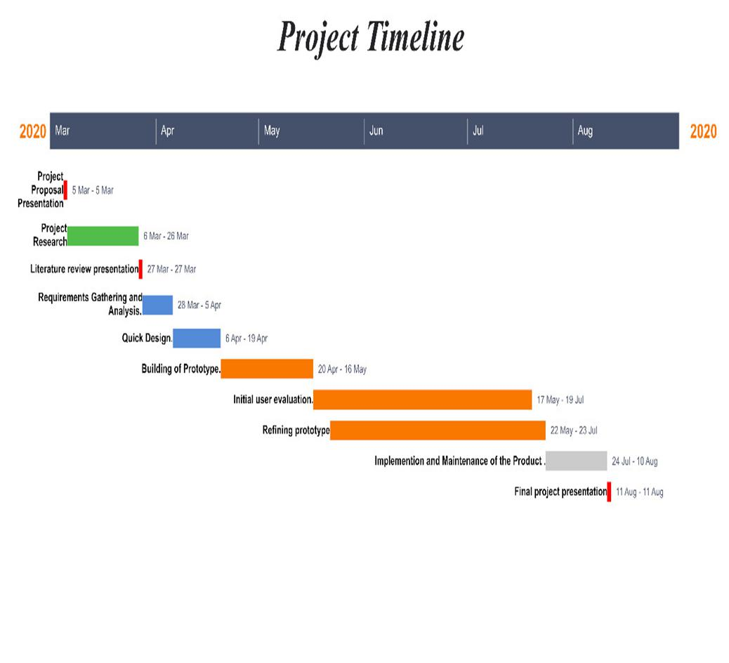

 | Stage |  |  | Start date |  |  | End Date |  |  | Duration
 | Project proposal |  |  | 5th March |  |  | 5th March |  |  | 1 day
 | presentation
 | Project research |  |  | 5th February |  |  | 26th March |  |  | 4 weeks
 | Literature review |  |  | 27th March |  |  | 27th March |  |  | 1 day
 | presentation
 | Requirements |  |  | 26th March |  |  | 8th April |  |  | 2 weeks
 | analysis
 | System design |  |  | 9th April |  |  | 29th April |  |  | 3 weeks
 | Coding and |  |  | 30th April |  |  | 28th July |  |  | 13 weeks
 | implementation
 | Integration and |  |  | 29th July |  |  | 11th August |  |  | 2 weeks
 | testing
 | Final project |  |  | August |  |  | August |  |  | 1 day
 | presentation

 |  |  |  |  | BUDGET
 |  |  |  | MONITORING
No |  | Item |  |  |  |  | Price
1 |  | DHT11 |  |  |  |  | Kshs500
1 |  | Photoresistor |  |  |  |  | Kshs50
1 |  | Soil Moisture Sensor |  |  |  |  | Kshs150
1 |  | Arduino |  |  |  |  | Kshs1600
1 |  | Esp8266 |  |  |  |  | Kshs1500
1 |  | pH Sensor |  |  |  |  | Kshs7500
 |  | TOTAL |  |  |  |  | Kshs 12, 000
 |  |  |  | REGULATION
No |  |  | Item |  |  |  |  | Price
1 |  |  | Peristaltic Pump |  |  |  |  | Kshs2000
1 |  |  | 2 channel Relay |  |  |  |  | Kshs1200
1 |  |  | Solenoid Valve |  |  |  |  | Kshs2000
1 |  |  | Bulb |  |  |  |  | Kshs50
1 pkt |  |  | Transistors |  |  |  |  | Kshs1000
1 |  |  | Heating Element |  |  |  |  | Kshs1600
1 |  |  | Humidifier |  |  |  |  | Kshs3000
 |  |  | TOTAL |  |  |  |  | 10, 850

CONCLUSION

We conclude by taking an excerpt from the quartz article, "If farms are to survive, we need to think about them as tech companies. And that means they should be taking advantage of what many other industries are already harnessing: automation."

Automation of the food industry is a powerful tool to ensure food security and an automated approach of monitoring and regulation of elements in farming is one of its many solutions.
CHAPTER 2: LITERATURE REVIEW

INTRODUCTION

The goal of this section is to show how an automated system can be used to achieve food security.

An article by quartz (Alexandria, 2018)on automated food production supports this by stating the following:

- World Resources Institute suggests we will need to double our food production by 2050 to feed nearly 10 billion people. In order to boost yield, we need to systematically improve the entire grow process and maximize the potential of every plant. To enable this next age of agriculture, we will need to rely on two new advances: machine learning and robotics.

- The amount of data available to farmers has skyrocketed. In addition to collecting data at a macro level from satellite or drone imagery, we can also capture data at the micro level, thanks to a combination of cheaper, lower-powered sensors. These sensors provide farmers with insights like hyper local measurements on soil conditions.

- Automation allows for a more accurate work environment with little human oversight. It will involve hardware that is more precise than the human eye or hand, and it will be able to give each and every plant the unique attention it needs

PROBLEM STATEMENT

The following are challenges currently facing farmers in their attempt to achieve food security:

- Growing demand for food -With an estimated 9 to 10 billion people that need to be fed by 2050, it’s not only a matter of producing more food but also making healthier food more accessible and affordable for the masses (trends, 2017).

- Human Capital – High demand for food has led to the establishment of large-scale farming that in turn requires a large labor force. Thus, leading to higher cost of food production brought about by wages for workers.

- Climate Change - The effects of climate change have been felt mostly by the farmers especially due to dependence on rain-fed agriculture. Areas which previously received adequate rainfall now receive insufficient rainfall reducing the land that can support agriculture. This brings the need for more exploitation on irrigation farming especially in ASALs. It is estimated that intensified irrigation can increase agricultural productivity fourfold and, depending on the crops, incomes can be multiplied 10 times (trends, 2017)

.
RESEARCH QUESTION

The research was guided by the following questions

- How can IOT be used to automate monitoring and regulating elements in farming?

- What benefits does automation of monitoring and regulating elements in farming give to the farmer?

STUDY OBJECTIVES

To study the subject of IOT in an effort to understand its implementation in automating monitoring and regulation of elements in farming.

To study how real-time data can be availed from a remote server to a mobile application.

To study the impact of automated monitoring and regulation of elements in farming along with the various benefits it brings to the farmers.

OVERVIEW OF IOT

The internet of things, or IoT, is a system of interrelated computing devices, mechanical and digital machines, objects, animals or people that are provided with unique identifiers (UIDs) and the ability to transfer data over a network without requiring human-to-human or human-to-computer interaction.

IoT devices share the sensor data they collect by connecting to an IoT gateway or other edge device where data is either sent to the cloud to be analyzed or analyzed locally. Sometimes, these devices communicate with other related devices and act on the information they get from one another.
STATEMENT USE CASES

The following are cases similar to ours where which IOT was used:

- Gardening + Arduino by Luke Iseman (Iseman, 2020) is an IoT solution that aims to automate gardening. The elements in consideration are Light and soil moisture. The key difference between Gardening + Arduino and the proposed solution is:

  - The number of elements in consideration. Gardening + Arduino focuses on two elements, Light and Soil moisture while the proposed project will focus on Light, Humidity, Soil moisture, Temperature and soil pH.

  - Gardening with Arduino does not offer a platform for which the user can monitor the elements remotely.

- SmartAgro by Andrei Florian (Florian, 2019) is an IoT solution that aims to monitor the soil in an agricultural field or greenhouse, and visualize the data remotely. Unlike with our project it does not include regulation of the various elements.

REALTIME HANDLING OF DATA

Firebase allows us to store and sync data with their NoSQL cloud database. Data is synced across all clients in Realtime, and remains available when your app goes offline.

The Firebase Realtime Database is a cloud-hosted database. Data is stored as JSON and synchronized in Realtime to every connected client. It supports cross-platform and therefore works with iOS, Android and JavaScript SDKs.
BENEFITS OF AUTOMATING MONITORING AND REGULATION IN FARMING

The impacts of automating monitoring and regulation of elements in farming are:

- Convenience

- Reduce costs.

- Robust yields.

How is it convenient?

Remote monitoring and regulation allow the user to save on time excluding the need for user presence on site.

How does it reduce costs then?

Reduces the labor spent in monitoring and regulating of the elements manually using devices.

How does it bring about robust yields?

Customized profiling of plants will allow farmers to yield more robust produce.
CHAPTER 3: SYSTEM ANALYSIS AND DESIGN

INTRODUCTION

There are two sections namely:

- System Analysis: We will analyze the system’s feasibility through the following feasibility studies:
  - Technical feasibility study.

  - Economic feasibility study.

  - Operational feasibility study.

In addition, we will determine both non- functional and functional requirements.

- System Design: Here we aim to describe the design of our system using appropriate diagrams.

SYSTEM ANALYSIS

FEASIBILITY STUDY

TECHNICAL FEASIBILIYT STUDY

The project is an IOT solution aided with the use of an Android application. The main technologies and tools that are associated include:

- Sensors and regulators (Examples: Moisture sensor and pump).

- Micro controller.

- C programming language.

- Java programming language.

- Firebase Database.

- Android Studio.

- Gliffy Diagramming Software.

The proposed solution is technically feasible not only because the forementioned technologies and tools are readily available but also the necessary technical expertise is possessed.
ECONOMICAL FEASIBILTY STUDY

The development and maintenance of the project is expected to incur the following costs:

- Development and purchasing costs

- Hardware cost – This is the cost of purchasing the sensors, regulators and micro-controllers.

- Operational costs

- Bandwidth cost – Data handling cost across the network.

- Reduces the labor spent in monitoring and regulating of the elements manually using devices.

- Remote monitoring and regulation allow the user to save on time excluding the need for user presence on site.

- Customized profiling of plants will allow farmers to yield more robust produce.

- The project is economically feasible since the benefits reduce operational cost, which being recurring outweigh the development cost.

OPERATIONAL FEASIBILITY STUDY

The project is operational feasible by achieving the following:

- Fast response time – Attributed by the fact that the user receives information in real-time.

- Reduced manpower – Attributed by the fact that user presence is not required on site.

- Accessibility – Attributed by the fact that monitoring and regulation of the elements is remote.

- Reliability – Attributed by the fact that human errors are eliminated hence results from measurement are consistently accurate.
REQUIREMENTS STUDY

FUNCTIONAL REQUIREMENTS

The system should perform the following functions:

- Measurement of elements - Micro-controller should facilitate the measurement of elements through the use of sensors.

- Creation of the database and recording of measurements of the elements – The database will store measurements of elements.

- Display of measurements - An android application should display the measurements of the elements from the real-time database.

- Regulation of the elements - Micro-controller should facilitate the regulation of the elements by the use of the regulators.

NON-FUNCTIONAL REQUIREMENTS

The system achieves the following non-functional requirements:

- Performance – High response time and low network throughput.

- User friendliness.

- Maintainability: Through the use of alarms.
SYSTEM DESIGN

This section covers 2 levels of system design:

- Low-Level: This is a representation of the hardware components as used in the circuits.

- High-Level: These are diagrammatical representations of the interactions between the user and the system.

LOW-LEVEL DESIGN

The circuit is made up of:

- ESP8266 Micro-controller.

- Humidity and temperature sensor.

- A relay.

- A fan.

- Breadboard.

- Wires.
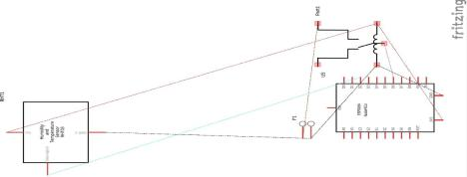
HIGH LEVEL DESIGN

USE CASE DIAGRAM
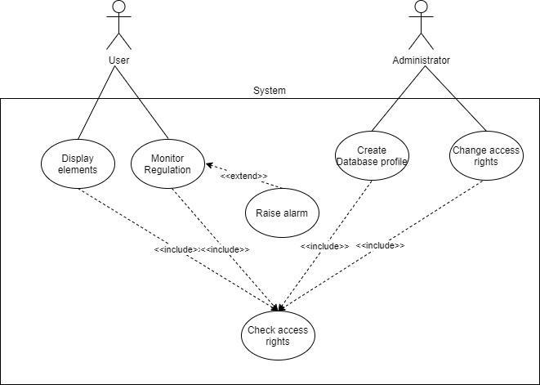

ACTIVITY DIAGRAM
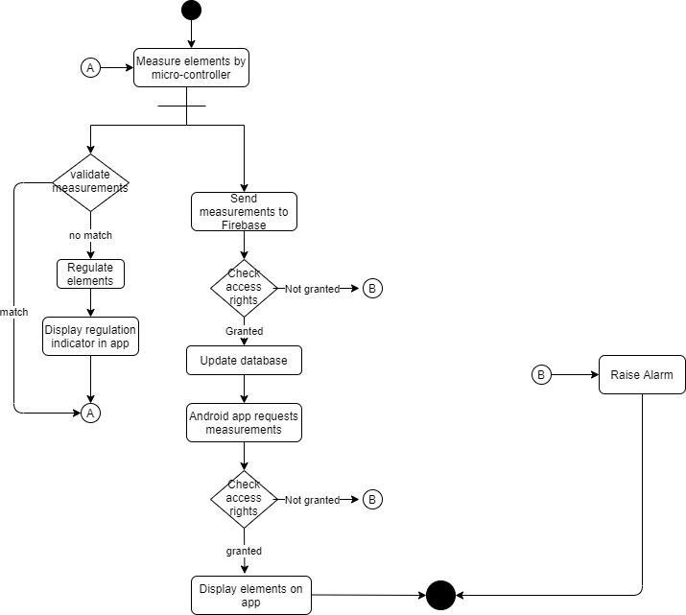
CHAPTER 4: SYSTEM CODE GENERATION AND TESTING

INTRODUCTION

Topics of Discussion:

- Hardware Components.

- Monitoring light, humidity and temperature and updating of Realtime database (Firebase).

- Displaying values on Android app.

- Remote regulation.

SYSTEM CODE GENERATION

WIFI CONNECTON:

#define WIFI_SSID "…......."

#define WIFI_PASSWORD "…......"

#define FIREBASE_HOST "practicals001-default-rtdb.firebaseio.com" #define FIREBASE_AUTH "ENXolIBUTbEHkjBQYgJ9lDx1KAFEuddFaHae3uPg" void setup() {

wifiConnect();

Firebase.begin(FIREBASE_HOST, FIREBASE_AUTH); delay(10);

}

void wifiConnect()

{

WiFi.begin(WIFI_SSID, WIFI_PASSWORD); // Connect to the network
Serial.print("Connecting to ");

Serial.print(WIFI_SSID); Serial.println(" ...");

int teller = 0;

while (WiFi.status() != WL_CONNECTED)

{ // Wait for the Wi-Fi to connect

delay(1000);

Serial.print(++teller); Serial.print(' ');

}

Serial.println('\n');

Serial.println("Connection established!");

Serial.print("IP address:\t");

Serial.println(WiFi.localIP()); // Send the IP address of the ESP8266 to the computer

}

ELEMENT DATA COLLECTION BY SENSOR SUING LIGHT, TEMPERATURE AND HUMIDITY AS EXAMPLE:

int LDRPin = A0; // select the input pin for ldr

dht DHT;

#define DHT11_PIN D3 // digital pin 7

void loop() {

// Light:

sensorValue = analogRead(LDRPin);

Serial.println("Sensor Value: ");

Serial.println(sensorValue); //prints the values coming from the sensor on the screen
// Humidity and Temperature.

int chk = DHT.read11(DHT11_PIN); // measure humidity and temperature.

Serial.println("Temperature: ");

Serial.println(DHT.temperature); //prints the values coming from the sensor on the screen Serial.println("Humidity: ");

Serial.println(DHT.humidity); //prints the values coming from the sensor on the screen

}

DATA TRANSFER TO FIREBASE FROM MICROCONTROLLER:

void loop() {

Firebase.setInt("LightIntensity", sensorValue); //setup path and send readings

- Humidity and Temperature. Firebase.setInt("Humidity", int(DHT.humidity));

Firebase.setInt("Temperature", int(sensorValue));

delay(1000);

}

DATA RETRIEVAL FROM FIREBASE USING LIGHT AS AN EXAMPLE:

void loop() {

// Light

lightReg = Firebase.getInt("lightReg");

userReg = Firebase.getInt("userReg");

delay(1000);

}
ELEMENT REGULATION USING LIGHT AS A CASE EXAMPLE:

if(int(userReg) == int(1)){

if(int(sensorValue) < int(300) || int(lightReg) == int(1)){ digitalWrite(led, HIGH);

}

else{

digitalWrite(led, LOW); // Turn the LED on

}

}else{

digitalWrite(led, LOW); // Turn the LED on

}

DATA CAPTURE FROM FIREBASE BY ANDROID APP FOR DISPLAY PURPOSE

var humidity: TextView = findViewById(R.id.humidity_value)

var light : TextView = findViewById(R.id.light_value)

var temp : TextView = findViewById(R.id.temperature_value)

var ph: TextView = findViewById(R.id.soil_ph_value)

var moisture : TextView = findViewById(R.id.soil_moisture_value)

val button_light: Button = findViewById(R.id.button_light)

val button_temp: Button = findViewById(R.id.button_temperature)

val button_humidity: Button = findViewById(R.id.button_humidity)

val button_moisture: Button = findViewById(R.id.button_moisture)

val button_ph: Button = findViewById(R.id.button_ph)

val user_regulate: Button = findViewById(R.id.user_regulate)

DATA TRANSFER TO FIREBASE BY ANDROID APP FOR REGULATION PURPOSE:

button_light.setOnClickListener {

ChangeRegulateValue3()

}

private fun ChangeRegulateValue3(){

if ( lightReg == 0){

database.child("lightReg").setValue(1)

}else{

database.child("lightReg").setValue(0)

}

}

TESTING

The method of testing used was component testing. We tested the data collection components which included:

- WIFI connection.

- Data transfer to Realtime database (Firebase) from Microcontroller.

- Data retrieval from Realtime database (Firebase).

- Regulation of Light element.

- Data Capture by Android app from Realtime database (Firebase).

- Data transfer to Realtime database from Android app.

Upon the successful completion of the tests on each component, integration testing was done to affirm that the components were working together. The test was successful.

This is a link to videos of our testing:

https://drive.google.com/drive/folders/13SWD4_EaL2UgXADwdb8BACWOgFgoHHSF?usp=shari ng
CONCLUSIONS

The project was a success and the objectives were met.

LIMITATIONS AND RECOMMENDATIONS

The sensors within the system require calibration when which left unattended could lead to inaccurate results.

Dependency on constant supply of power could make deployment is remote areas without access to power difficult. A work around to this limitation is the use of solar panels to power the devices.

REFERENCES

Alexandria, B. (2018, October 8). Retrieved from Iotforall: iotforall.com/iot-applications-in-agriculture

Florian, A. (2019, June 7). smartAgro. Retrieved from Arduino:

create.arduino.cc/projecthub/LightPro

Iseman, L. (2020, March 4). Gardening + Arduino. Retrieved from Instructibles:

instructables.com/id/Garduino-Gardening-Arduino

Rahman, A. (2020, March 4). Regulation of light. Retrieved from Instructables:

instructables.com/id/Arduino-Light-Sensor

Ravindra, S. (2020, January 3). Retrieved from Iotforall: iotforall.com/iot-applications-in-agriculture

Tatge, J. (2020, March 4). Retrieved from Farmobile: farmobile.com/

trends, F. (2017, December 21). 4 farming challenges that need to be addressed. Retrieved from farmerstrends: farmerstrend.co.ke/4-farming-challenges-need-addressed/

